1. **Explain the purpose of DevOps Architecture and its significance in modern software development.**

DevOps combines development and operations to increase the efficiency, speed, and security of software development and delivery compared to traditional processes. A more nimble software development lifecycle results in a competitive advantage for businesses and their customers.

DevOps is a continuous cycle, often depicted as an infinity symbol, where the 'final' stage connects to the 'first', to emphasize the continuing nature of the process.

The stages in DevOps are:

• Plan

• Code & Assemble

• Build

• Test

• Release

• Deploy

• Operate

• Monitor

* There are variations on this approach, sometimes naming 'release' and 'deploy' continuous integration & continuous deployment (CI/CD). At its core, the cycle is intended to manage a series of handoffs between different responsibilities in a more fluid, iterative way.
* DevOps can be best explained as people working together to conceive, build and deliver secure software at top speed. DevOps practices enable software development (dev) and operations (ops) teams to accelerate delivery through automation, collaboration, fast feedback, and iterative improvement. Stemming from an Agile approach to software development, a DevOps process expands on the crossfunctional approach of building and shipping applications in a faster and more iterative manner. In adopting a DevOps development process, you are making a decision to improve the flow and value delivery of your application by encouraging a more collaborative environment at all stages of the development cycle.DevOps represents a change in mindset for IT culture. In building on top of Agile, lean practices, and systems theory, DevOps focuses on incremental development and rapid delivery of software. Success relies on the ability to create a culture of accountability, improved collaboration, empathy, and joint responsibility for business outcomes.
* DevOps is a combination of software development (dev) and operations (ops). It is defined as a software engineering methodology which aims to integrate the work of development teams and operations teams by facilitating a culture of collaboration and shared responsibility

**4) Define DevOps and Agile and highlight the key differences between these two approaches to software development.**

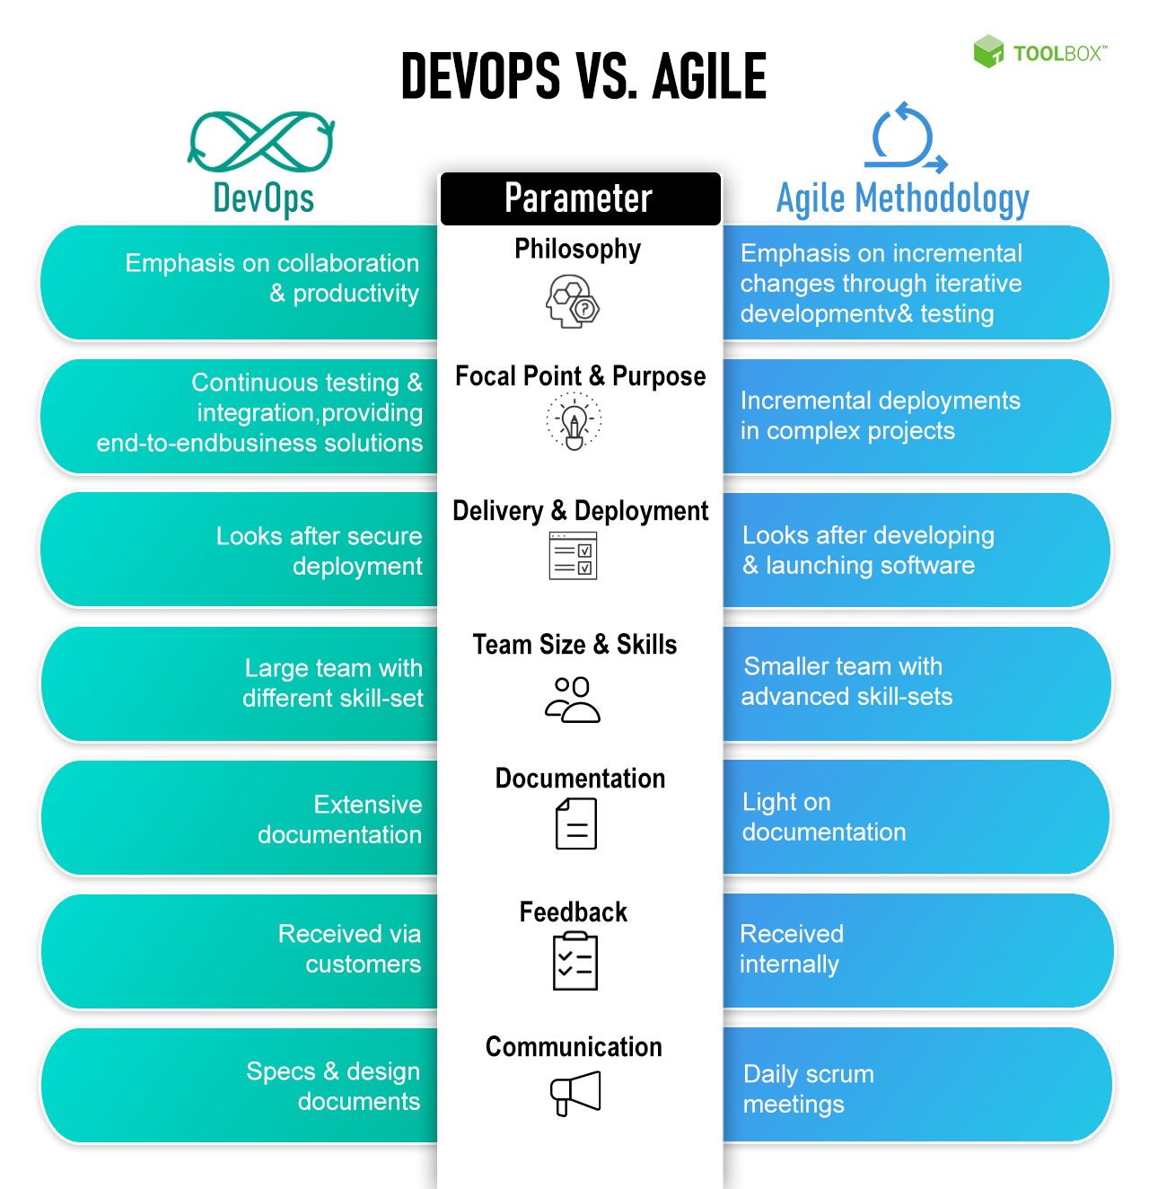

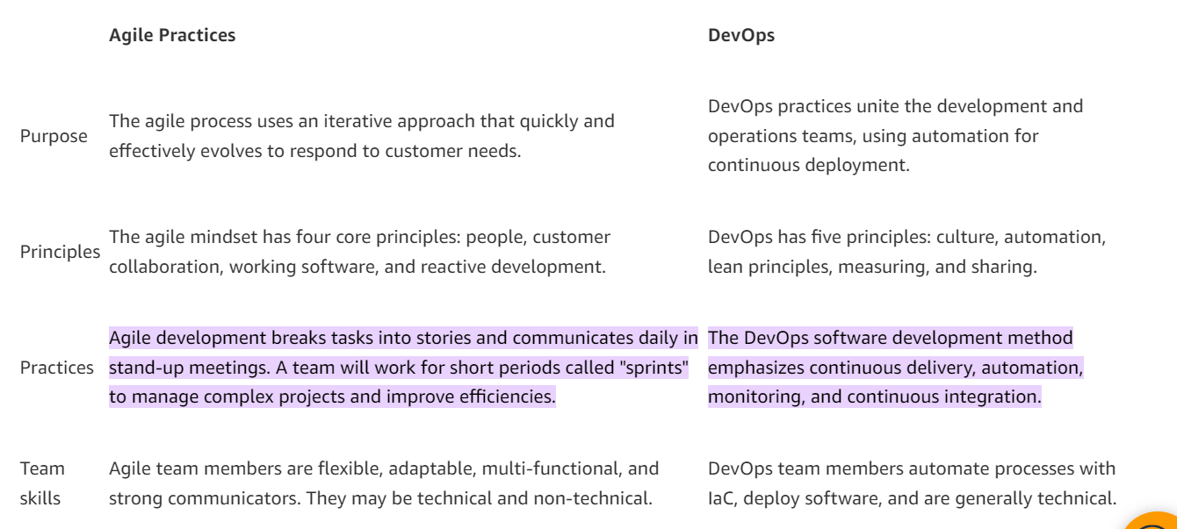

**7)** Explain the concept of Continuous Integration (CI) and Continuous Delivery (CD) in the context of DevOps. Why are they essential in DevOps practices?